EX NO: 7 DATE:
SERVLET PROGRAMMING

AIM:
To write the program for the given problems using servlet

ALGORITHM:
STEP 1. HTML Form Setup:
- Create an HTML form for movie search with method `post`.
- Include an input field for the search term (`searchTerm`).

STEP 2. Servlet Initialization:
- Define a servlet class named `greet` that extends `HttpServlet`.

STEP 3. Request Processing:
- Override the `doPost` method to handle POST requests.
- Inside `doPost`:
- Retrieve user's name (`uname`) and selected language (`select`) from request parameters.
- Create cookies for `uname` and `select`.
- Add cookies to the response.
- Generate greeting messages based on the selected language.
- Write HTML response with greetings and farewell messages.

STEP 4. Response Generation:
- Set response content type to "text/html;charset=UTF-8".
- Get PrintWriter object to write HTML content.

STEP 5. Cookie Management:
- Create cookies for storing user's name and selected language.
- Add cookies to the response.

STEP 6. Greeting Message Selection:
- Use if-else conditions to determine the greeting message based on the selected language.
- Generate personalized greeting messages based on language selection.
- Write the HTML content including the greeting message and a farewell message in the selected language.

PROGRAM 1 :
<!DOCTYPE html>
<html>
<head>
<title>Movie Search</title>
</head>
<body>
<h1>Movie Search</h1>
<form action="http://localhost:38947/WebApplication14/MovieSearchServlet" method="post">
<label for="searchTerm">Search by Title or Actor:</label><br>
<input type="text" id="searchTerm" name="searchTerm" required><br><br> <input type="submit" value="Search">
</form>
</body>
</html>

import java.io.IOException; import java.util.ArrayList; import java.util.List;
import javax.servlet.ServletException; import javax.servlet.annotation.WebServlet; import javax.servlet.http.HttpServlet; import javax.servlet.http.HttpServletRequest; import javax.servlet.http.HttpServletResponse;

@WebServlet("/movies")
public class MovieServlet extends HttpServlet { private static final long serialVersionUID = 1L; // Dummy movie data private List<Movie> movies = new ArrayList<>();

public MovieServlet() { // Sample movie data movies.add(new Movie("Inception", "Leonardo DiCaprio"));
movies.add(new Movie("The Shawshank Redemption", "Tim Robbins, Morgan Freeman")); movies.add(new Movie("The Godfather", "Marlon Brando, Al Pacino")); movies.add(new Movie("The Dark Knight", "Christian Bale, Heath Ledger"));
}

protected void doGet(HttpServletRequest request, HttpServletResponse response) throws ServletException, IOException {
String action = request.getParameter("action");

if ("search".equals(action)) {
String query = request.getParameter("query"); List<Movie> searchResults = searchMovies(query); request.setAttribute("movies", searchResults); request.getRequestDispatcher("/movies.jsp").forward(request, response);
} else { request.setAttribute("movies", movies); request.getRequestDispatcher("/movies.jsp").forward(request, response);
}
}

private List<Movie> searchMovies(String query) { List<Movie> results = new ArrayList<>(); for (Movie movie : movies) {
if (movie.getTitle().toLowerCase().contains(query.toLowerCase()) || movie.getActors().toLowerCase().contains(query.toLowerCase())) { results.add(movie);
} } return results;
}
}

OUTPUT:

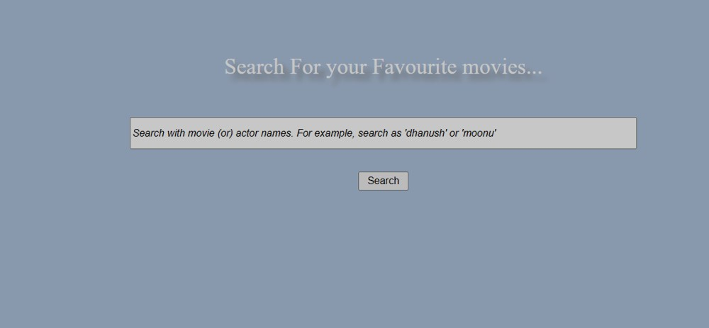

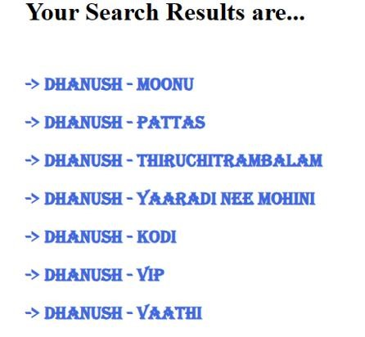

PROGRAM 2 :

<!DOCTYPE html>
<html lang="en">
<head>
<meta charset="UTF-8">
<meta name="viewport" content="width=device-width, initial-scale=1.0">
<title>Create Quiz</title>
<link rel="stylesheet" type="text/css" href="styles.css">
</head>
<body>
<h1>Create Quiz</h1>
<form action="QuizServlet" method="post">
<label for="question">Question:</label>
<input type="text" id="question" name="question" required><br>
<label for="answer">Answer:</label>
<input type="text" id="answer" name="answer" required><br>
<button type="submit">Add Question</button><br><br>
</form>

<h2>Quiz Preview</h2>
<ul>
<!-- Servlet will populate this list -->
</ul>
</body>
</html>

import java.io.IOException; import java.io.PrintWriter; import java.util.ArrayList;
import javax.servlet.annotation.WebServlet; import javax.servlet.http.HttpServlet; import javax.servlet.http.HttpServletRequest; import javax.servlet.http.HttpServletResponse; import javax.servlet.http.HttpSession;

@WebServlet("/QuizServlet")
public class QuizServlet extends HttpServlet {
protected void doPost(HttpServletRequest request, HttpServletResponse response) throws IOException {
String question = request.getParameter("question");
String answer = request.getParameter("answer");

HttpSession session = request.getSession();
@SuppressWarnings("unchecked")
ArrayList<String> quiz = (ArrayList<String>) session.getAttribute("quiz");

if (quiz == null) { quiz = new ArrayList<>(); session.setAttribute("quiz", quiz);
}

quiz.add("Q: " + question + " - A: " + answer);

response.sendRedirect("index.html");
}
}

OUTPUT:

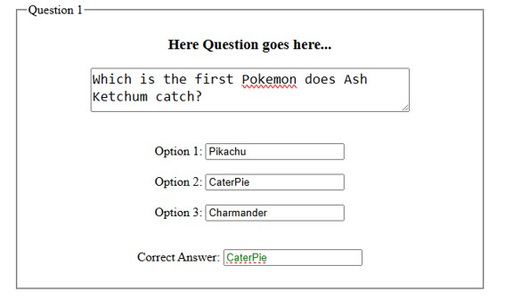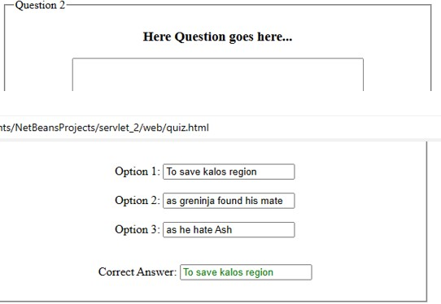

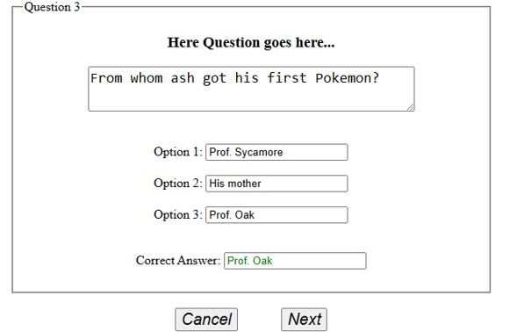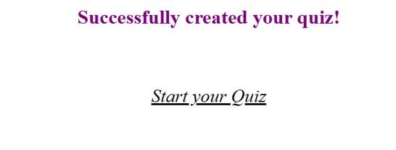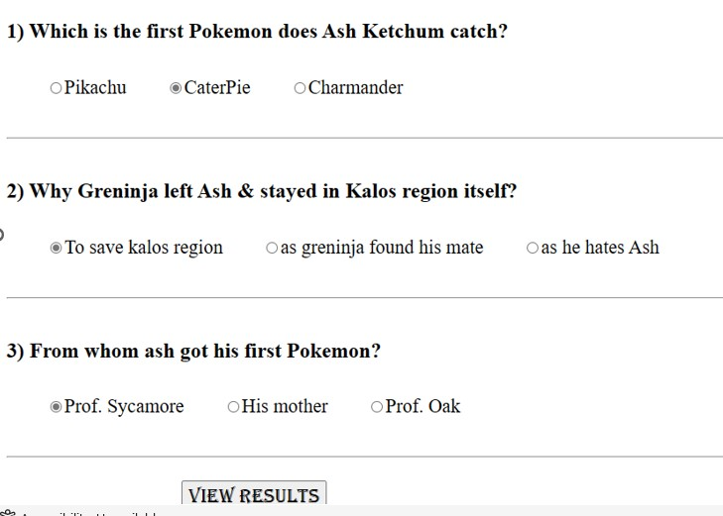

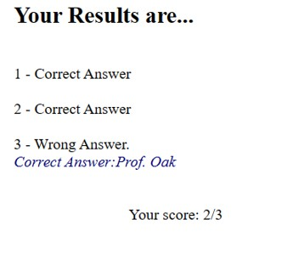
PROGRAM 3:
<!DOCTYPE html>
<html lang="en">
<head>
<meta charset="UTF-8">
<meta name="viewport" content="width=device-width, initial-scale=1.0">
<title>Language Selection</title>
</head>
<body>
<h1>Select Your Preferred Language</h1>
<form action="LanguageServlet" method="post">
<label for="language">Preferred Language:</label>
<select id="language" name="language">
<option value="english">English</option>
<option value="french">French</option>
<option value="spanish">Spanish</option>
</select>
<button type="submit">Submit</button>
</form>
</body> </html>
import java.io.IOException;
import javax.servlet.ServletException; import javax.servlet.annotation.WebServlet; import javax.servlet.http.Cookie; import javax.servlet.http.HttpServlet; import javax.servlet.http.HttpServletRequest; import javax.servlet.http.HttpServletResponse;

@WebServlet("/LanguageServlet")
public class LanguageServlet extends HttpServlet {
protected void doPost(HttpServletRequest request, HttpServletResponse response) throws ServletException, IOException {
String language = request.getParameter("language");

// Store the selected language in a cookie
Cookie cookie = new Cookie("preferredLanguage", language); cookie.setMaxAge(30 * 24 * 60 * 60); // Cookie valid for 30 days response.addCookie(cookie);

// Redirect to the greeting page response.sendRedirect("GreetingPage");
}
}
import java.io.IOException; import javax.servlet.ServletException; import javax.servlet.annotation.WebServlet; import javax.servlet.http.Cookie; import javax.servlet.http.HttpServlet; import javax.servlet.http.HttpServletRequest; import javax.servlet.http.HttpServletResponse;

@WebServlet("/GreetingPage")
public class GreetingPage extends HttpServlet {
protected void doGet(HttpServletRequest request, HttpServletResponse response) throws ServletException, IOException {
// Retrieve preferred language from cookie
String language = "";
Cookie[] cookies = request.getCookies(); if (cookies != null) { for (Cookie cookie : cookies) { if (cookie.getName().equals("preferredLanguage")) { language = cookie.getValue(); break;
}
}
}

// Display greeting in the preferred language String greeting = ""; switch (language) { case "english":
greeting = "Hello!"; break; case "french":
greeting = "Bonjour!"; break; case "spanish":
greeting = "¡Hola!"; break; default:
greeting = "Hello!";
}

response.setContentType("text/html"); response.getWriter().println("<h1>" + greeting + "</h1>");
}
}
OUTPUT:

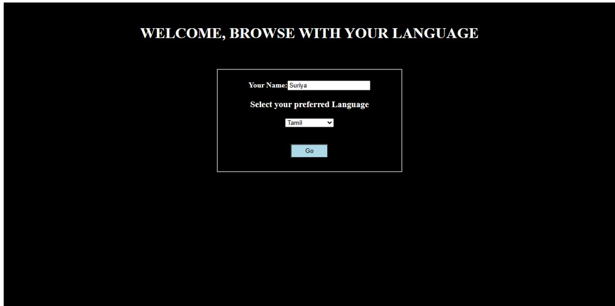

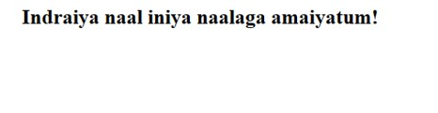

RESULT:
Program for the given problems are done and output is verified successfully

